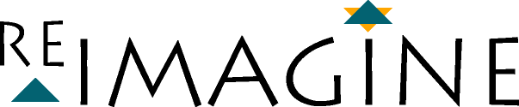

Re-Imagine is a two year program designed to create an alternative model of Jewish education within the religious school.

Vision Statement: North Shore Synagogue

We envision a congregation where learning permeates every aspect of our synagogue.

We envision a congregation:
- whose members recognize and value the mitzvah of life-long Jewish learning.
- whose members recognize that their fellow congregants are created b'tselem eloheem (in the image of God) and that together it is possible to create an ever more sustaining, nurturing and spiritual synagogue community.
- whose programs introduce, acquaint, deepen and enhance our learners' connection to God and the rich history, culture, language, music and traditions of the Jewish people.
- whose programs in religious education are characterized by creativity, energy, engagement, purpose, involvement, depth, discovery, and enthusiasm.
- whose programs draw lines of connection between our members, Israel, and the larger Jewish and human communities.
- whose programs assist members of all ages to more fully understand, embrace and practice their Judaism.
- where the study of Torah and practice of Judaism is experienced as engaging, enjoyable, and empowering.
- where the study of Torah and practice of Judaism leads to the performance of g'milut chasadim (deeds of loving-kindness) and tikkun olam (repairing the world).
- where the connection between learning and doing is reflected in the homes and lives of our members.
- where members practice Judaism with joy, and cherish their membership in this congregation and the Jewish people.

