The RE-IMAGINE Project Task Force Chair as Communicator

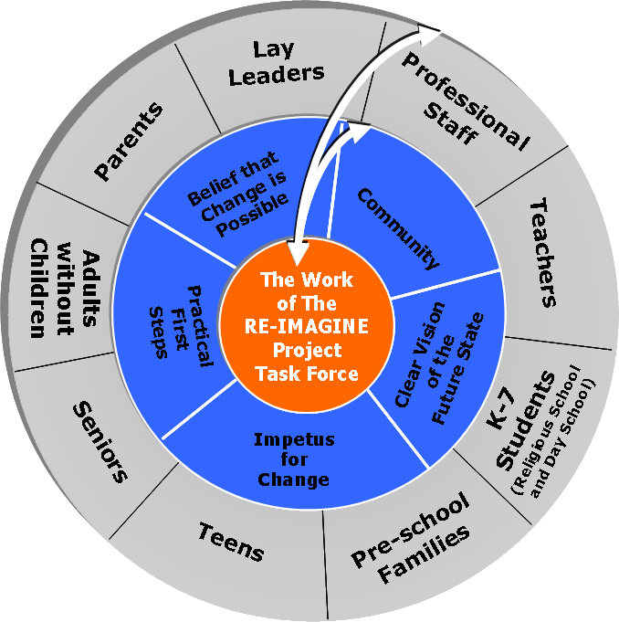

RE-IMAGINE Project Task Force is representative of all the various communities within the congregation. Establishing ongoing, two-way communication between members of the Task Force and the communities they represent creates a dynamic exchange of experiences and ideas. The RE-IMAGINE Project Task Force works in concert with the communities it represents rather than in isolation from them. In your role as Task Force Chair, you have the responsibility to ensure that communication flows regularly and productively between Task Force and congregation and back again.

Questions for discussion:
- Describe the kind of communication between congregation and Task Force that has taken place thus far. What are you communicating about and to whom? Who else needs to hear your message? What are you hearing back from the congregations, teachers, board etc?

- This graphic places the conditions for change within the circle of communication. Which of these conditions is the larger congregation already hearing about? In communicating these conditions, what have you learned about the potential costs of change within your congregation?

